Resource Page
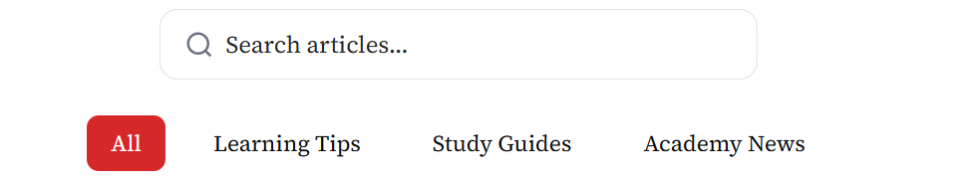
English Learning Tips & Academy Announcements
Study guides, tips, and news from Myanmar New Era.

  Academy News  Student Activity Day  📅 06/03/2026  Myanmar New Era will organize a Student English Activity Day with games, speaking activities, and group discussions.  Read More → |   Academy News  New General English Batch  📅 05/03/2026  A new General English class for Beginner and Elementary levels will start soon. Limited seats are available.  Read More → |   Academy News  New IELTS Preparation Class  📅 04/03/2026  Registration is now open for the new IELTS preparation program. Students will practice Listening, Reading, Writing, and Speaking with experienced instructors.  Read More →
  Study Guides  Vocabulary Learning  📅 03/03/2026  Learn 5-10 new words daily. Use flashcards and try to write your own sentences using the new vocabulary.  Read More → |   Learning Tips  Listening Practice  📅 02/03/2026  Listen to podcasts, English songs, or short videos every day. Using subtitles can help you understand pronunciation and sentence patterns better.  Read More → |   Learning Tips  Daily Reading Tips  📅 01/03/2026  Read English for about 15 minutes every day. You can read newspapers, short stories, blogs, or simple English books. Daily reading helps improve vocabulary and comprehension.  Read More →
Join Our Learning Community
Stay updated with English learning tips, new programs, and academy announcements by following our blog.

